Made Naradeon Handika Pramesta

103032300101

1. ---------------------------------------

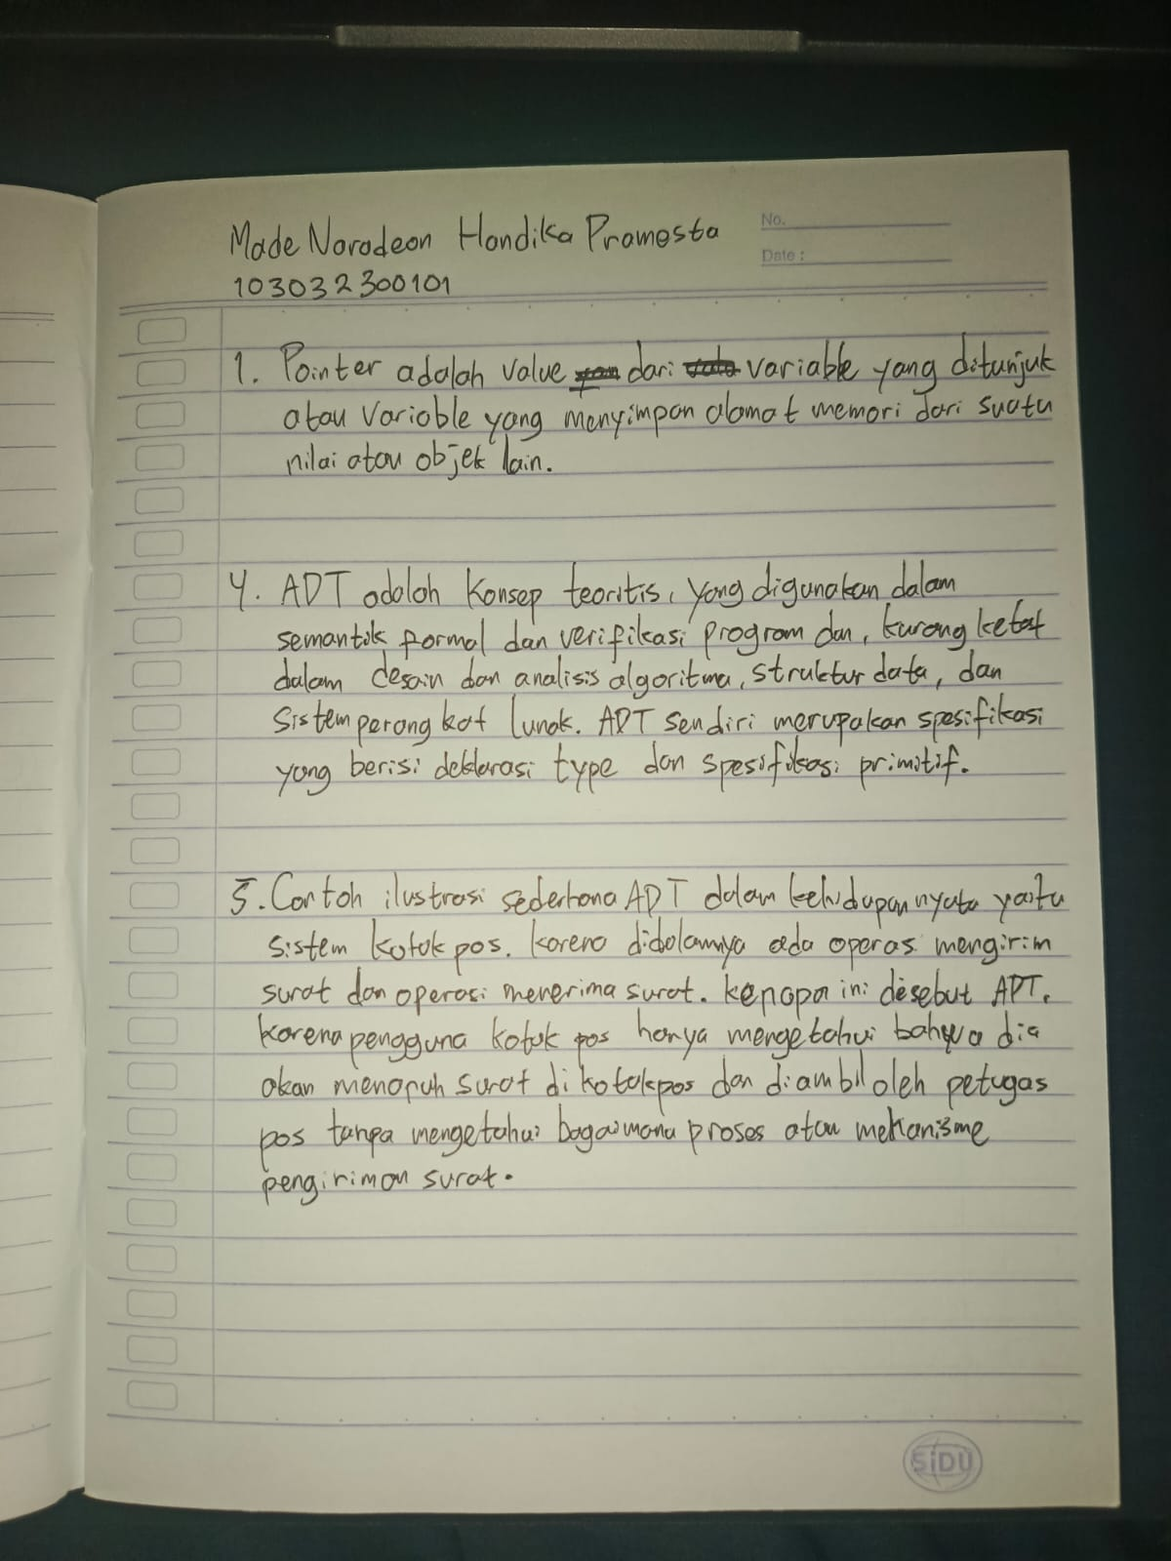

1. -----------------------------------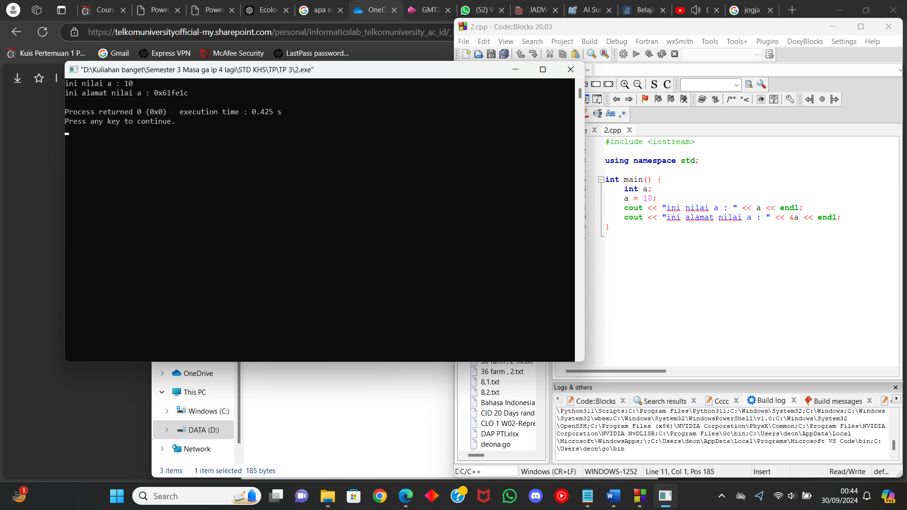
2. -----------------------------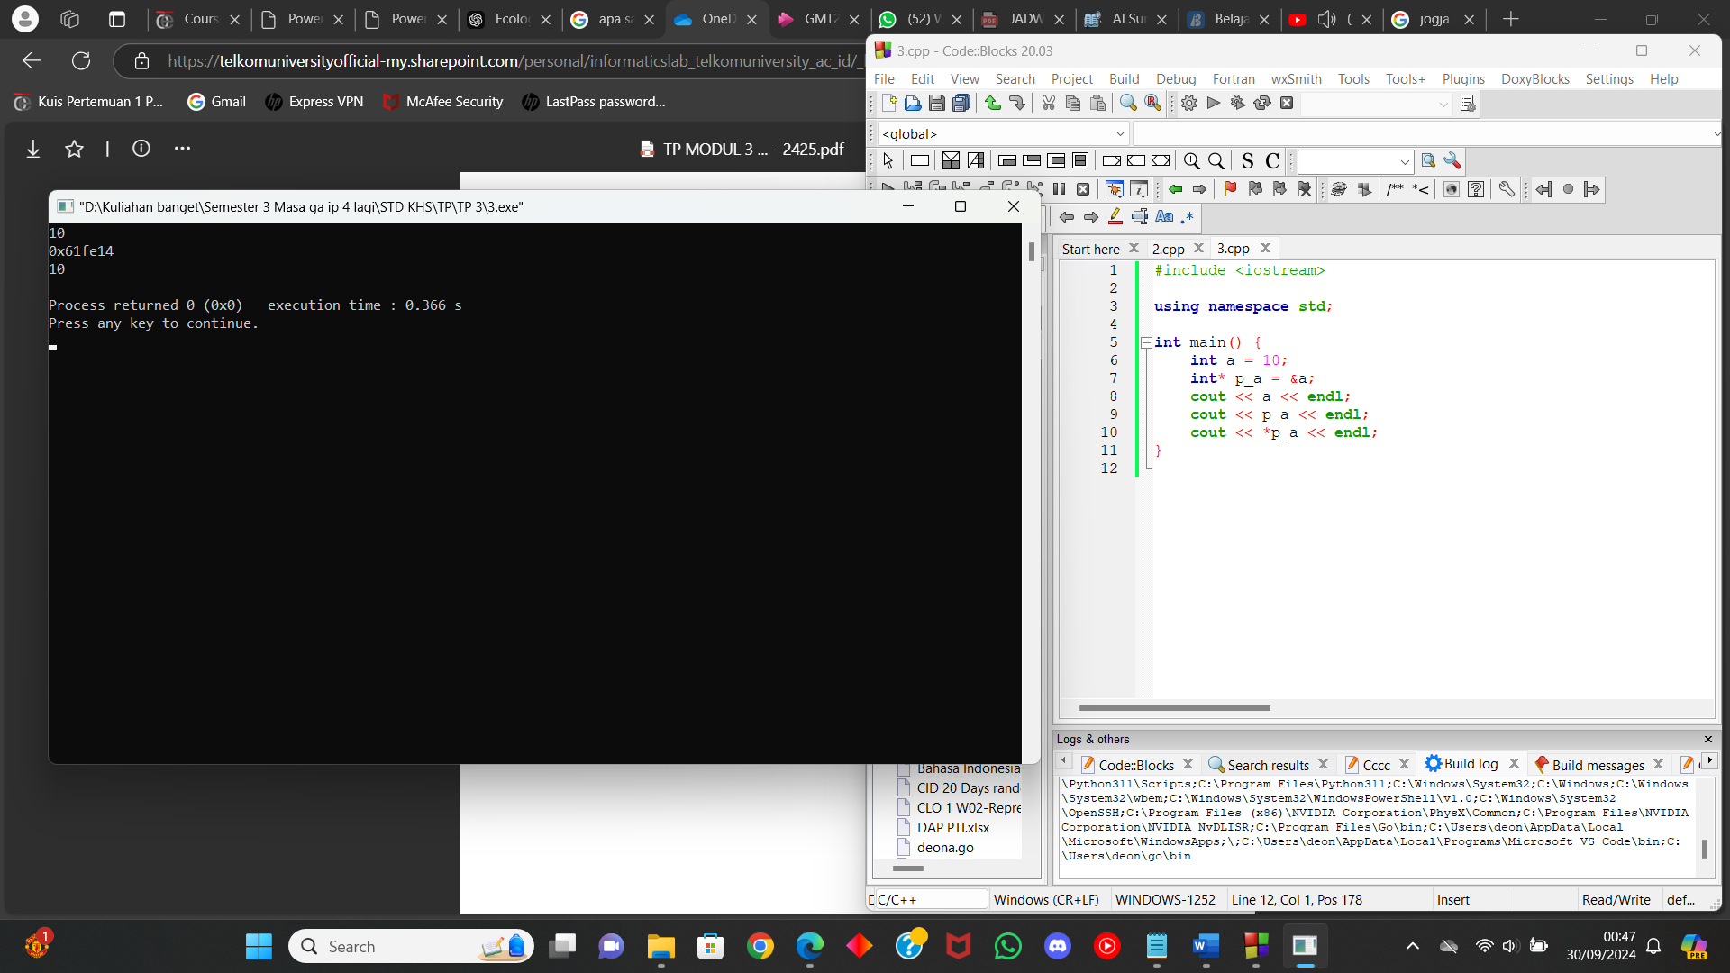
3. -------------------------------



1. -----------------------------



1. ----------------------------------------------